# How many candy crush levels are there?

**Candy crush is one of the most played games globally, with 873 episodes having 13,085 levels on the HTML5 version, while on the Windows 10 App version, there are an additional 105 levels. Read on to learn more.**

Are you familiar with Candy Crush Saga? As an adult, at one point, you may have downloaded the famous game, given how trendy it got. If you have a smartphone, that’s enough to get you to play Candy Crush. What started as a Facebook game advanced to be available on android and IOS. There are new levels each year; if you need to catch up on which levels are in the game, the review below will inform you of that. Also, understand how to get to the next level on Candy Crush.

## Types of levels in Candy Crush

Candy Crush is a Swedish-developed mobile game by King Digital Entertainment. However, later on, Activision Blizzard gained ownership. It got into the market in April 2012 as a Facebook game and later advanced to a mobile app.

If this is the first time you have played the game, it involves switching different tiles with Candy in different colors. When you match three or more consecutive similar Candy, they disappear while the ones above descend automatically. In turn, you get awarded points.

Candy Crush has levels placed in episodes. In each episode, there are several levels. For instance, Candy Factory and Candy Town, the first two episodes, each have ten levels while the rest have 15. There are five Candy Crush levels, Order, Jelly, Ingredients, Mixed Mode and Rainbow Rapids. They accumulate to 13,085 levels from 873 episodes.As you progress playing, there are levels that you get to cross. Let's have a better look at the levels below.

**Order**

In this level, the game requires you to create a sequence of a certain amount of Candy in a specific color, get a particular type of Candy or get rid of special blocks. Once you complete these, you advance to the next level; if you fail, you try until you get it right.

**Jelly**

As the name of the level suggests, here you deal with jelly. The game requires you to match jelly blocks in a sequence, either horizontally or vertically. They could be three or more matching blocks of jelly. Once you complete this level, you can proceed to the next.

**Ingredients**

The ingredients level is different from the rest of the other levels. Here there are arrows to which you need to bring the ingredients blocks. The arrows are at the tail end of each column. If you finish taking the ingredients, you will earn points and proceed.

**Mixed Mode**

Here, there are different obstacles that you deal with. The game mixes the two types of levels, which creates a more complex level that requires skill. It would help if you were fast, intelligent, and ready. Before you get to the last type of level, there are different episodes that you go through while in Mixed Mode.

**Rainbow Rapids**

The name says it all; you need to clear rainbow candy. You get to this step after completing 7,000 levels. As you did in the previous levels, here you will rid other blocks of getting rainbow candy.

Sadly, Dreamworld, which was part of the levels, was recently removed. It had 45 episodes with 665 levels; for each episode, there were 15 levels except for two, Funky Factory and Sleepy Slopes, which had ten episodes.

Summary table of levels in Candy Crush Saga

|  |  |
| --- | --- |
| **Type of level** | **Number of levels** |
| **Candy Order** | 3308 |
| **Jelly** | 2015 |
| **Ingredients** | 2551 |
| **Mixed Mode** | 4753 |
| **Rainbow Rapids** | 413 |

## Is there an end to candy crush?

Yes, it has. The first level is Candy Order, while the highest is Rainbow Rapids. If you complete all the levels, you will beat the game, and that will be the end. However, there are new-level additions each week. Therefore, it will be soon that you get to play.

As you begin the game, you start with a simple level; as you advance, it gets more challenging. You cannot skip a level to get to the next; you must go through each step. You have to solve a specific puzzle for each level within a given period of clicks.

## Conclusion

As we have seen, Candy Crush is a well-known game that came into the market in 2012. Since then, there have been advancements in the game, making it more popular among gamers. As of 2022, the game has five levels; Order, Jelly, Ingredients, Mixed Mode and Rainbow Rapids amounting to 13,085. You go from one level to another.

The initial steps are straightforward; however, as you go further, it gets more challenging. After completing each step, some rewards come in the form of points. Each week there are new level releases; therefore, be on the lookout for your favorite game. If you have yet to try the game, download it and give it a try.

## FAQs

**How many levels are there in Candy crush?**

There are five types of levels; Candy Order, Jelly, Ingredients, Mixed Mode and Rainbow Rapids. They follow that order. Therefore you have to complete one level to get to the next. In each group, some episodes have several levels. In total, there are 13 085 levels.

**What is the highest level in Candy Crush?**

Rainbow Rapids is the highest in Candy Crush, while Candy Order is the least or first.

**Is it hard to unlock Candy Crush levels?**

As you begin playing, the first two levels are simple to complete. Making a sequence is jelly, and Candy is easy to do. However, as you proceed, it gets more challenging, especially in the last level, Rainbow Rapids. As with any other game, if you perfect the game, it becomes more accessible, whereas a beginner, they'll have a hard time.

**Can you reach the end while playing Candy Crush?**

Contrary to what you may think, there is an end while playing Candy Crush. Once you complete all levels, you beat the game.

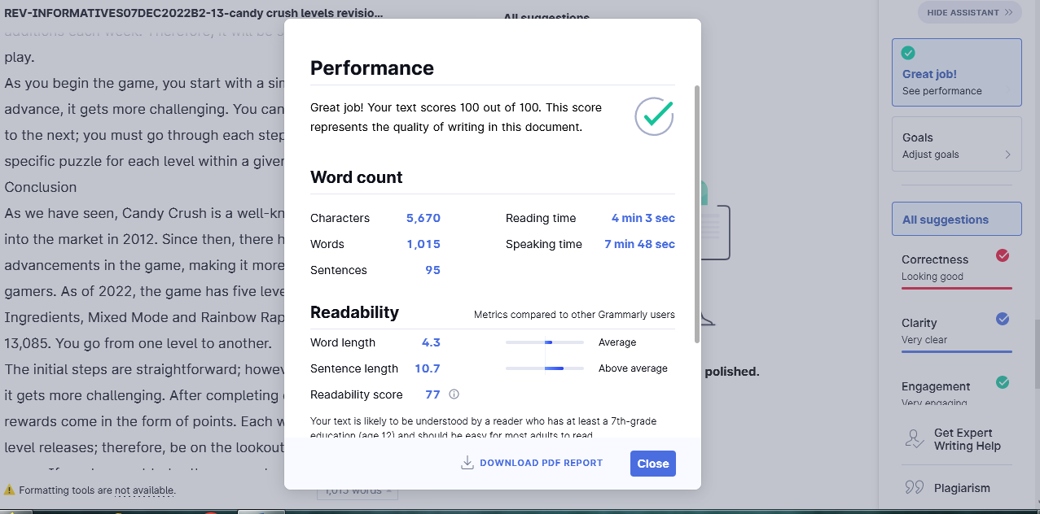

**Editor’s Report**

|  |  |
| --- | --- |
| **Specific Client Instructions** | **Editor’s Comments** |
| Target answer | present |
| Introduction | Well covered |
| Subheadings | Relevant to the topic |
| Overall quality | Great |